Environmental Council Report for President Patton, May 1, 2017 Draft

The 2016-17 Environmental Council focused its efforts in three areas this year:

1) a sustainability pledge and benefit for employees;
2) development of a pilot project to explore the feasibility of a travel carbon surcharge; and
3) defining sustainability literacy for discussion and adoption by the Middlebury community.

Following are summaries of the three committees’ reports. The full report of each committee follows the summaries.

A. Summaries

1. Sustainability Pledge and Benefit Project for Middlebury College Employees

The Sustainability Pledge and Benefit Committee has worked to put in place a one-time benefit opportunity for all Middlebury College employees who would like to take action to reduce their household carbon and ecological footprint impacts. Working with a $30,000 gift from a local family given to support carbon neutrality the committee has crafted a program that offers up to a $200 reimbursement for actions and purchases that will diminish household carbon and ecological impacts in energy, food and transportation. Lower income employees who are eligible for support from Vermont’s 3SquaresVT program can receive up to $250.

The benefit has three steps. First employees review tips and resources about how to go about reducing these impacts. Second, they select an action or purchase they will make and sign a pledge to do so. Third, after fulfilling the pledge they submit proof and request reimbursement for their action. The benefit will be added to their next paycheck.

The eligible items for the benefit are items that employees agree to undertake for the first time and were selected partly for their potential to be valuable enough to be continued on their own after the benefit period. We will conduct a follow up assessment in year to gauge the continuity of actions. We have made provisions to be sure to level the field for those employees who may not have regular access to a computer so that they may get their pledge and requests in without a lag time relative to employees with regular computer access.

We have made it clear that this is a one-time, first come-first serve benefit and that once the funds are disbursed no further pledges and benefit reimbursements will be accepted. We hope that we can reach a significant number of employees and that this will prompt them to take actions that will become a habit in the future. We also are offering the benefit in celebration of the College’s recent achievement of carbon neutrality.

The benefit program launches May 4, 2017 and will run until June 5, 2017. We anticipate that the funds will be fully committed but if not, we will offer a second round of opportunity.
2. Travel Carbon Surcharge Pilot Program

Although Middlebury College has reached its Carbon Neutrality goal, College operations continue to emit significant carbon. These greenhouse gases currently are offset by carbon sequestered in the Bread Loaf lands. As a sustainability leader, Middlebury College has an obligation to continue reducing its gross carbon emissions as well as its reliance on offsets. Over 25 percent of the College’s carbon emissions are produced by College-funded travel. Therefore, the Environmental Council recommends that each department be charged for the carbon cost of its travel, and that the resulting funds be invested in projects to reduce carbon emissions from other College operations (e.g., building weatherization).

3. Defining Sustainability Literacy

Our group chose to move forward under "sustainability literacy" in place of "environmental literacy" after an internal discussion. Our final definition is as follows, however we have reservations about moving forward with this definition.

"Sustainability literacy is the consciousness of how one's actions impact society and the environment, and the application of that knowledge to one’s decision-making, in order to ensure equitable access to resources for the holistic well-being of people and ecosystems. This knowledge would aid in sustaining and improving social and environmental systems for present and future generations. Middlebury College recognizes sustainability literacy as a fundamental and critical skill both on an individual and institutional level."

We recommend that an operational component of this definition and integration be the focus moving forward and that this process should involve a representative from the administration, faculty, staff, and the student body.

--

4. 2016 – 2017 Members of the Environmental Council

Students
Samuel Alexander '20
Oriyomi Adeliyi '20
Jimmy Conboy '20
Tatiana Rengifo '19.5
Calla Rosenfeld '19
Anna Novak '19
Hunter Cole '18.5
Tevan Goldberg '18
Michael Shrader '18
Abbie McCeney '18
Jack Petrillo '18
Mariah Nielsen '18
Jennifer Ortega '18
Elana Feldman '17.5
Graham Kenter '17.5
Ali Surdoval '17
Sarah Gledhill '17

Faculty
David Allen, Biology, Co-Chair
Molly Anderson, Food Studies
Ellery Foutch, American Studies
Alison Nurok, Biology

Staff
Jack Byrne, Director, Office of Sustainability Integration, Co-Chair
Eva Fillion, Outreach/Communications Coordinator, Office of Sustainability Integration
Katie Gillespie, Research Compliance Manager
Victoria "Tori" Jones, Assistant Director Annual Giving
Charlotte Tate, Rohatyn Center for International Affairs

Anahi Naranjo '17
Morgan Raith '16.5
Caitlin Haedrich '16.5

B. Committee Reports

1. Sustainability Pledge and Benefit Project for Middlebury College Employees -
Reimbursement for pledging and reducing your household carbon footprint

One of our core values at Middlebury is a commitment to leadership in environmental stewardship and sustainability. As a way to support this value and to celebrate our recent achievement of carbon neutrality, Middlebury is encouraging employees to reduce their personal carbon footprint by taking advantage of this Sustainability Pledge Benefit.

The Sustainability Pledge Benefit encourages Middlebury employees to reduce their household and transportation carbon footprints by:

- Learning about actions that can be taken by individuals to reduce carbon emissions from energy use at home and/or transportation choices,
- Pledging to take first time actions to reduce carbon emissions from a list of actions which can be reimbursed through the pilot program,
- Taking your pledged first-time action and then submitting an application for reimbursement with proof of the action or purchase.

The Sustainability Benefit In 2017

Middlebury will offer employees up to $200 towards qualifying sustainability purchases or actions. Employees whose household incomes are eligible for 3SquaresVT benefit can receive up to $250 towards qualifying sustainability purchases or actions (see table below for information regarding eligibility).

This benefit is made possible by a generous gift from a local donor to support carbon neutrality at Middlebury College. It is being offered until the funds are used up. Sometime after that limit is reached, we will assess the impact of the benefit program. A key part of the assessment will focus on whether the employee plans to continue the benefit they were reimbursed for without the Sustainability Benefit subsidy (e.g. renew membership in a CSA (community supported agriculture)).

Middlebury is partnering with Vermont Energy Investment Corporation (VEIC) to offer you this benefit. Middlebury is part of a larger consortium of Vermont employers who are offering similar benefit projects including: VEIC, National Life of Vermont, Benn and Jerry’s, Seventh Generation, and King Arthur Flour.

How to Access the Sustainability Pledge Benefit

Getting reimbursed for your Sustainability Pledge Benefit is a 3-step process:

- Review the tips on how to reduce household and transportation carbon emissions included in this packet at the program website (link)
- Choose one or more of the actions and purchases that are eligible for the benefit and
sign the pledge to reduce carbon emissions and the specific actions you will take.
- Take your qualifying action and/or make your purchase and complete the reimbursement form with proof of purchase and eligibility to Office of Sustainability Integration, Room 109, Franklin Environmental Center, 531 Hillcrest, Middlebury, VT 05753.

After submitting the form and proof of purchase/action you will receive your reimbursement, added to your paycheck minus taxes shortly after.

Qualifying Sustainability Benefit purchases

The following lists provide information about qualifying sustainability purchases and actions. Note that the maximum benefit available for each participating employee is $200. Employees whose households receive 3SquaresVT benefits can receive up to $250 towards qualifying sustainability purchases or actions (see table below for information regarding eligibility)

Partial Reimbursement

The following items are eligible for a reimbursement of 50% - up to the maximum benefit of $200, or 75% reimbursement up to the maximum of $250 for employees whose household incomes are eligible for 3SquaresVT benefit – see table below for information regarding eligibility.

• Community Supported Agriculture (CSA) share purchase

• Food Hub shares/purchases

• Membership in a local food cooperative

• Bulk food purchase from a farmer

• Seeds, soil, small food plants, fruit trees or native trees for planning and growing for family consumption

• Composting equipment or service

• Rain barrel or other water conservation vessel

• Cost of classes, workshops, etc. related to home gardening and/or eating vegetarian

• ZipCar or similar membership

• A $50 reward for switching from single occupancy vehicle work commuting to:

- carpooling,
- biking,
- walking, or
- public transport

five or more times over a one-month period (sign a statement of verification and optional: submit a photo showing you engaged in those activities).

Full Reimbursement

The following items are eligible for 100% Reimbursement - up to the maximum benefit of $200. Employees whose household incomes are eligible for 3SquaresVT benefit can receive a maximum of $250 reimbursement – see table below for information regarding eligibility:

• Bicycles (for the employee to use for going to work).

• ENERGY STAR appliances, windows and doors, high efficiency heating and cooling products, smart thermostats and other energy efficiency products eligible for a rebate from Efficiency Vermont – see complete list of products eligible for residential buildings here.

• Low flow and energy efficient water devices

• A home energy efficiency audit conducted by an Efficiency Vermont listed contractor – see here for info.

• Complete a home energy upgrade project (example: a Home Performance with ENERGY STAR project).

• Renewable-energy systems (solar, wind, geothermal).

• Electric lawn mower purchase.

NOTE: we will accept a signed contract for efficiency upgrades, renewable energy system installation and other longer term items as proof of purchase to establish eligibility for the reimbursement. We will hold the appropriate amount for benefit payment and issue it when a receipt showing completion of the project is provided.

Not Eligible for Benefit: bike accessories or apparel, car repairs/maintenance or car parts, grocery store purchases, butcher’s/farmer’s market purchases, gardening equipment.

--

Income Guidelines for 3SquaresVT (Oct 2015)
To qualify, your net household income must be less than 100% of the federal poverty level (FPL) based on household size. Net household income = gross income minus allowable deductions.

Household Size | Maximum Gross  Monthly Income  (185% of FPL) | Maximum Net  Monthly Income  (100% of FPL)
1 | $1,832 | $990
2 | $2,470 | $1,335
3 | $3,108 | $1,680
4 | $3,746 | $2,025
5 | $4,385 | $2,370
6 | $5,023 | $2,715
7 | $5,663 | $3,061
8 | $6,305 | $3,408
9 | $6,947 | $3,755
10 | $7,589 | $4,102
Each additional  member add | $642 | $347

Allowable Deductions
Allowable deductions include:
- A standard deduction based on household size
- An earned income deduction (20% of earned income)
- The cost of child/dependent care
- Court-ordered child support paid to another household
- Shelter expenses (up to a maximum amount)
- Some medical expenses for household members age 60+ or with a disability

Step 1: Review the Sustainability Tips and Resources Page at:

http://www.middlebury.edu/sustainability/academics-and-research/environmental-council/sustainability-pledge-benefit/tips-and-resource

Step 2: Sustainability Benefit Pledge Form and Return

Date:
Name:
Department:
ID#:

Home Street Address:
City:
State:
Zip:
Phone:
Email:

Do you receive 3SquaresVT assistance? Yes___ No___ Initial if you checked “yes” __________
-----

Partial reimbursement items:

I pledge to take one or more of the following actions, which I have not done before now, to reduce my household carbon emissions (check all that apply):

___ Community Supported Agriculture (CSA) share purchase

___ Food Hub shares/purchases

___ Membership in a local food cooperative

___ Bulk food purchase from a farmer

___ Seeds, soil, small food plants, fruit trees or native trees for planning and growing for family consumption

___ Composting equipment or service

___ Rain Barrel or other water conservation vessel

___ Take a class, workshops, etc. related to home gardening and/or eating vegetarian

___ ZipCar membership or similar

___ Switch from single occupancy vehicle work commuting to one of the following alternatives five or more times over a one-month period:

- carpooling,
- biking,
- walking, or
- public transport

This option requires you to sign a statement of verification and optional: submit a photo showing you engaged in those activities.

Full Reimbursement Items

The following items are eligible for 100% Reimbursement - up to the maximum benefit of $200. Employees whose household incomes are eligible for 3SquaresVT benefit can receive a maximum of $250 reimbursement – see table below for information regarding eligibility:

___ Purchase and use a bicycle for commuting to work.

___ ENERGY STAR appliances, windows and doors, high efficiency heating and cooling products, smart thermostats and other energy efficiency products eligible for a rebate from Efficiency Vermont – see complete list of products eligible for residential buildings here. [ Check for wood/pellet stoves]

___ Obtain a home energy efficiency audit conducted by an Efficiency Vermont listed contractor – see here for info.

___ Complete a home energy upgrade project (example: a Home Performance with ENERGY STAR project).

___ Install a renewable-energy systems (solar, wind, geothermal).

___Purchase an electric lawn mower.

Upon completion of the pledged items, I will submit an application for reimbursement with proof of completion [Link] and request the Sustainability Benefits I am eligible for.,

Signed: _________________________________________
Date: ____________________
Step 3: Reimbursement Application Form
(Fill out and return after you have completed your pledge)

Date:
Name:
Department:
ID#:
Position #

Home Street Address:
City:
State:
Zip:
Phone:
Email:

Do you receive 3SquaresVT assistance? Yes___ No___ Initial if you checked “yes” __________
-----
Reimbursement Request

Part I. Please list any items for which you are requesting partial reimbursement (up to maximum total of $200 ($250 for employees who qualify for 3SquaresVT)

Item Amt. Paid Reimb. Request (50% OR 75% if
qualified for 3SquaresVT)

Subtotal _______ ________
-----
Part II. Please list any items for which you are requesting full reimbursement up to the maximum of $200 ($250 for employees who qualify for 3SquaresVT)

Item Amt. Paid Reimb. Request (50% OR 75% if
qualified for 3SquaresVT)

Subtotal _________ _________
-----
Part III. I am requesting the $50 benefit for switching from single occupancy vehicle commuting to a lower carbon commuting mode.

I attest to have completed an alternative commute to work five or more times over a one month period by one or more of the following means:

- carpooling,
- biking,
- walking, or
- public transport

Signed: ___________________________________________________________

TOTAL Sustainability Benefit Requested

Total sustainability benefit reimbursement request - cannot exceed $200 (or $250 for employees who qualify for 3SquaresVT): ______________

Signature: __________________________________________________

Date: _________________________

Please attach original receipts for qualified purchases and return to:

Office of Sustainability Integration, Room 111 Franklin Environmental Center, 531 Hillcrest, Middlebury, VT 05753.

2. Travel Carbon Surcharge Pilot Project

Definitions
- Greenhouse gas: Any atmospheric gas that absorbs and reflects thermal infrared radiation. The primary greenhouse gases in our atmosphere are water vapor, carbon dioxide, methane and nitrous oxide. In the last 250 years human activities have increased the concentration of the last three of these gases, causing an increase in global temperature and other global climate changes.
- Metric tons of carbon dioxide equivalent (MTCDE): This is the standard unit of measure for greenhouse gases. Each greenhouse gas has a different ability to trap heat in the atmosphere. For a quantity of greenhouse gases the CO₂e is the amount of CO₂ that would have the equivalent greenhouse effect. The CO₂e is a useful term to put all greenhouse emissions into a single value. The MTCDE is a unit of greenhouse gases that has the same greenhouse effect as one metric ton of CO₂.
- “Carbon”: in this report we will use the term “carbon” to refer to greenhouse gases. This is a common convention (e.g., “carbon neutrality”).

Rationale
On Dec. 8, 2016 the College announced it had reached its Carbon Neutrality goal. Given the College’s commitment to being a suitability leader, this announcement is not an end point. Carbon emitted by college activities is offset by carbon sequestered on the Breadloaf lands. At the same time, it is still important to reduce carbon emitted by College activities. Travel is responsible for over a quarter of College carbon emitted. The Environmental Council would like to see a program implemented which made makes each department responsible for the carbon cost of its travel. We see three benefits of such a program: (1) It would educate students, staff, and faculty on the impact of their activities. Middlebury is an educational institution and should look for this type of “outside the classroom” learning initiative. (2) It will provide a fund for further carbon sequestration and avoided emissions programs. And, (3) if the College comes out in support of larger carbon pricing initiatives, this program will show that the College “puts its money where its mouth is.”

Structure of proposed program
How budgeting would work
In the proposed program each department would be charged for the carbon their travel is estimated to have emitted. Based on conversations with Mike Thomas, the easiest way such a program would be implemented would be:
- Each fiscal year a department’s budget would be charged based on its travel in the previous fiscal year.
- For each travel type a metric tons of carbon dioxide equivalent (MTCDE) per travel dollar spent has been estimated by the Office of Sustainability.
- Carbon emitted from travel would be estimated from the amount spent in each travel-related Account Code (e.g., 706210 Airline — College Travel Expense) and the above MTCDE per dollar estimate.
- This MTCDE would be multiplied by the current price of carbon to calculate the amount charged to the department for its “Travel Carbon Tax.” We could use either a market price of carbon (right now approximately $10 per MTCDE, http://calcarbondash.org/) or a social price of carbon (estimated at $36 per MTCDE, https://www.epa.gov/climatechange/social-cost-carbon).

It would be more accurate to charge for the carbon emitted by distance traveled by each mode, but this is not tracked and would add a serious layer of complication. It would also have more of an immediate emotional effect if the charge could be applied at the time of travel. This would also be much harder to implement, according to Mike Thomas. As such we think the above method balances the desired effect of the program with what is feasible.
Using college-wide numbers provided to the Office of Sustainability we were able to estimate the total cost of this program. For FY16 the total cost of college-supported travel was $2.8M, and the total cost of the proposed program would be $32,000 for the market cost of carbon or $116,000 for the social cost. As a rough guide the program would add between 1.1% and 4% to the cost of travel.

Case study of cost to Advancement
College Advancement is a department within the college that has one of the highest levels of travel. As such, we reached out to them to share their travel numbers, that way we could see how much this program would affect their department. This would give a rough “ceiling” for the cost to other departments. Here is a summary for FY16.

Code | Type | Cost ($) | MTCDE/$ | MTCDE | Tax (market) | Tax (social)
706215 | Bus-College | $3,811 | 0.0002 | 0.93 | $9.33 | $33.59
706210 | Airline-College | $122,625 | 0.0015 | 178.92 | $1,789.16 | $6,440.96
706220 | Car Rental-College | $43,086 | 0.0014 | 61.63 | $616.26 | $2,218.53
706230 | Mileage-College | $20,872 | 0.0014 | 29.85 | $298.54 | $1,074.74
706250 | Train-College | $4,884 | 0.0006 | 3.11 | $31.05 | $111.80
706710 | Airline-Visitor | $1,802 | 0.0015 | 2.63 | $26.30 | $94.67
706715 | Bus-Visitor | $100 | 0.0002 | 0.02 | $0.24 | $0.88
706720 | Car Rental-Visitor | $226 | 0.0014 | 0.32 | $3.23 | $11.64
 | Total | $197,407 |  | 277.41 | $2,774 | $9,987

For Advancement this program would add between $2,774 and $9,987 to their cost of travel. This is 1.4% to 5% of their college travel, slightly more than the numbers quoted above. This is because Advancement spends most of its travel on airline and cars which are higher carbon per dollar compared to buses and trains. For student organizations that spend more on trains and buses the program should add less than 1% to their travel cost, if we use the market price.

What we would do with the funds
Funds raised from this program would be spent on carbon sequestration or avoided emissions projects. This group would prefer if the funds were used for projects internal to Middlebury, rather than spent on offsets bought on a third party market. That way, student, staff, and faculty would be more engaged with the project. Seeing the results of the funds on campus would hopefully encourage members of our community to think twice about their carbon emissions and provide a visual reminder of our impact. We have been in conversation with different people on campus about the best way to administer these funds.

Proposals for next year
Our long-term goal would be for the proposed program to be adopted by the senior leadership group. But we realize that it might be better to have some type of “phase in.” As such we see two possible steps forward before the full proposal:
- Institute a one-year voluntary pilot program with interested departments for the next fiscal year. This would give us a chance to work out any kinks in the system, see how much money is raised, and decide upon ways to most effectively use the funds.
- Institute a one-year study pilot program in which all departments are made aware of the carbon cost of their travel. In this case we start with the educational aspect of the program before instituting the tax itself.

We recommend that an Office of Sustainability Integration intern continues the study of this proposal over the summer, and then hands it off to an Environmental Council committee next academic year.
--

3. Sustainability Literacy (Formerly Environmental Literacy) Report

Upon meeting for the first time in September, our subcommittee began discussing the functional limitations of environmental literacy. By creating a definition for and promoting environmental literacy, social issues that are inextricable from environmental issues may be ignored, leading to an incomplete understanding of socioecological processes. Such misunderstandings often lead to actions that superficially and immediately improve that state of natural systems, but also detrimentally affect human populations that are a part of those natural systems. We decided that developing a definition for sustainability literacy would be more beneficial to the Middlebury community than developing a definition for environmental literacy.

Essentially, environmental literacy does not encompass social and economic aspects of environmental issues, while sustainability literacy does.

Operative goals for defining Sustainability Literacy Committee:
Determine how Middlebury should define sustainability literacy and how we should track progress toward greater literacy in the future.

Steps taken by the committee to define sustainability literacy:
- Literature review:
  - Each member of the committee independently found and reported on literature detailing comparable efforts and their outcomes through literature from peer institutions. Most notable of these papers were:
    - Moseley, C. (2000). Teaching for environmental literacy. The Clearing House, 74(1), 23.
    - Rowe, D. (2002). Environmental literacy and sustainability as core requirements: success stories and models. Retrieved March, 8, 2004.
    - Colucci‐Gray, L., Camino, E., Barbiero, G., & Gray, D. (2006). From scientific literacy to sustainability literacy: An ecological framework for education. Science Education, 90(2), 227-252.
    - Winter, J., & Cotton, D. (2012). Making the hidden curriculum visible: sustainability literacy in higher education. Environmental Education Research, 18(6), 783-796.
    - Corcoran, P. B., & Wals, A. E. (2004). Higher education and the challenge of sustainability. Dordrecht: Kluwer Academic Publishers.
    - Dawe, G., Jucker, R., & Martin, S. (2005). Sustainable development in higher education: current practice and future developments. A report for the Higher Education Academy, 87.
- Brainstorm and Idea Gathering:
  - Questioned what is important to Midd students and other groups on campus within subcommittee and with the help of the Environmental Council at large.
  - Critically analyzed peer institution definitions and decided to start from scratch.
  - Created list of words that may go in the definition based on values and ideas.
    - “Value, behavior, Motivation, Skills, Awareness, Knowledge, Problem-solving, Discussion, Reflection, Decision-making, Recognize, Enable, Empower, Transparency, Communication, Operational, Academic, Partners, future generations, past and present, natural systems, Harmony, welfare, humanitarian, conservation, human rights, well-being, productive, harmony, best practices, ensure, development, social systems, individually and collectively, social justice, Interconnectedness, Resource limits”
  - Created 5 definitions
- Internal (EC) feedback:
  - Solicited internal feedback on merits and weaknesses of each definition from the Environmental Council, leading to a consensus that a future definition should contain an operational portion, a knowledge portion, and accountability for individuals and institutions.
  - Revised definitions as we saw fit to reflect critiques.
  - Amalgamated definitions to narrow down to 2 definitions that encompassed subcommittee values, while still reflecting original differences.
- External feedback:
  - We decided after the process of internal review that we were not satisfied with the opportunity for critique. We as a committee recognized that the views of the EC are biased as we were all individuals involved in the process and may share similar viewpoints regarding the topic. Receiving input from individuals like professors and others was indispensable to allow us to address gaps and other issues and ideas we previously missed.
  - External feedback was collected through a google survey and sent to the EC, as well as select faculty members who we thought would provide a variety of perspectives with respect to the meaning of sustainability literacy.
  - Some feedback was not reflected in definition revisions because it did not anticipate a changing wealth of scientific knowledge and varying institutional positions on topics, both of which make it impossible to create an unchanging operational element.
  - Feedback can be found in the appendix.

Final Recommendation:
As we discussed in the first dialogues in the beginning of the year regarding this task, we recognize that because of this campus’ diverse voices, creating a singular definition to fit the Middlebury community would be a challenging task. This challenge became particularly salient towards the end of our process where we requested feedback from individuals outside the of the EC. Some individuals did not fully agree on the two final definitions compiled, as in one way or another they excluded certain aspects valuable to individuals. Because of the conflicted feedback we received with backlash to the definitions we provided, we are being extremely cautious as to how to move forward.
Definition as voted in final round of external/EC feedback:
- First Place: Sustainability literacy is the consciousness of how one's actions impact society and the environment, and the application of that knowledge to one’s decision-making, in order to ensure equitable access to resources for the holistic well-being of people and ecosystems. This knowledge would aid in sustaining and improving social and environmental systems for present and future generations. Middlebury College recognizes sustainability literacy as a fundamental and critical skill both on an individual and institutional level.
- Second Place: Sustainability literacy entails a multi-faceted knowledge of natural systems and social justice that enables and empowers individuals and organizations to conscientiously take action to conserve natural systems, while maintaining the highest level of well-being for all individuals, both present and future. The ultimate aim is to ensure a sustainable, global socio-ecological system. Middlebury College recognizes sustainability literacy as a fundamental and critical skill both on an individual and institutional level.

Moving Forward:

The EC Council recommends that the definition should not only go under further review with stakeholders and faculty, etc., but also that legal and administrative professionals affiliated with Middlebury College be involved in the formalization and implementation of this definition. Despite flaws and competing ideologies in the current definitions, we recommend that the EC begin work defining the operational element of the definition and a plan for implementation and literacy assessment. We recommend that the SGA cabinet environmental liaison be intimately involved in this process so that the broader student body can also be represented in this process.

- Guiding Questions for the Future:
  - How should the EC legitimate and disseminate this definition?
  - How should we measure sustainability literacy at Middlebury, and how often should we be tracking progress?
  - Should an action plan for acting on the definition be drafted too, and by whom?

Appendix:

Influential Definitions from Literature Review:

From Teaching for environmental literacy by Christine Moseley and adapted for sustainability:
"People tend to progress along the continuum of proficiency in [sustainability] literacy in stages that include awareness, concern, understanding, and action."
3 Stages:
- Nominal Literacy: Know basic terms, rudimentary understanding, no depth of knowledge
- Functional Literacy: Uses knowledge to understand and take stances on issues etc and can communicate meanings
- Operational Literacy: perceives issues, weighs options, takes stances, and questions and engages with the issues in daily life
"A person who is [sustainably] aware is not yet [sustainably] literate-nor is a person who possesses broad understanding of [sustainability], who demonstrates concern [over sustainability], or who takes action on a single [sustainability] issue. One demonstrates operational [sustainability] literacy only when all the components come together in the actions taken. "
From Environmental Literacy and Sustainability as Core Requirements: Success Stories and Models
“(Cortese 1999). [Learning about sustainability in this chapter refers to learning how to create both a more humane as well as an environmentally sound future for society. Sustainability at its best is about both an environmentally healthy future and a more equitable future (Ibid 1999).”
From Scientific Literacy to Sustainability Literacy: An Ecological Framework for Education
“The ability to deal with socioscientific issues, arising from the complex interactions of science and society, represents an integral component of scientific literacy and citizenship education….”
From Making the hidden curriculum visible: sustainability literacy in higher education
“Sustainability literacy is an umbrella term for the perspectives and insights that enable students to ‘understand the symbiotic relationships between environmental, social and economic dimensions of sustainable development’ “
- Appreciation of the importance of environmental, social, political and economic contexts for each discipline.
- A broad and balanced foundation knowledge of sustainable development, its key principles and the main debates within them.
- Problem-solving skills in a non-reductionist manner for highly complex real-life problems.
- Ability to think creatively and holistically and to make critical judgements.
- Ability to develop a high level of self-reflection.
- Ability to understand, evaluate and adopt values conducive to sustainability.
- Ability to bridge the gap between theory and practice; in sustainable development, only transformational action counts.
- Ability to participate creatively in interdisciplinary teams.
- Ability to initiate and manage change.
From Higher Education and the Challenge of Sustainability
“In contrast, the more recent Forum for the Future ‘definitional framework’ of sustainability literacy is at a far more general level. The highest overview of the framework is as follows:
- Understand the need for change to a sustainable way of doing things, individually and collectively
- Have sufficient knowledge and skills to decide and act in a way that favours sustainable development
- Be able to recognise and reward other people’s decisions and actions that favour sustainable development (Forum 2004)”
From the Suli Test (Related to Rio +20 Conference) : http://sulitest.org/en/vision-mission.html

“Sustainability Literacy is the knowledge, skills and mindsets that help compel an individual to become deeply committed to building a sustainable future and allow him or her to make informed and effective decisions to this end.”
From Sustainable Development in Higher Education
“Sustainability literacy encompasses learning how humans have immediate as well as long term impact on the economy and ecology of communities.”

External Feedback Results:
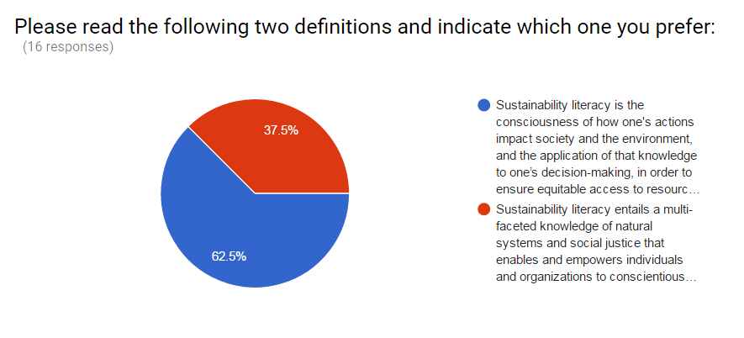
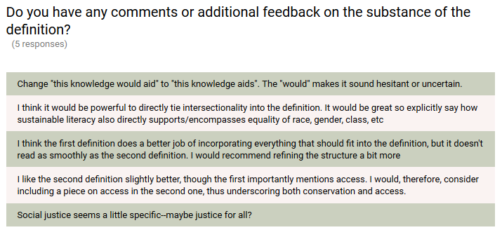
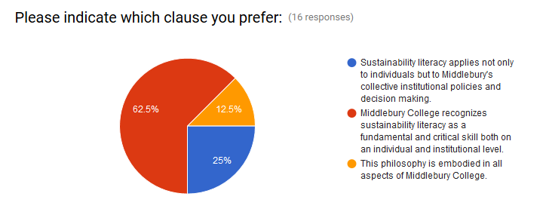

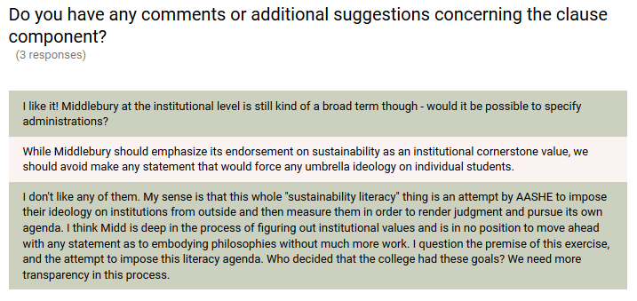

Anonymous feedback sent by email:
An anonymous respondent said of the definitions we developed that, “Both of them are very human-centric and do not emphasize non-human life forms and processes enough to meet what I humbly perceive as the needs of Earth’s aliveness, which we humans are blatantly and unethically impacting in many negative and destructive ways”. The respondent then listed specific ways in which the definitions we developed are anthropocentric, including, “society is placed before environment in the first definition, whereas human society is actually a nested component of the ecosphere (Earth’s largest ecosystem)” and “the second definition presents the idea of “the highest level of well-being for all individuals” – again very human-centric and includes the Assumption that all individual humans can have the highest level of something they/we/you/I/whomever judges to be in the interest of their and future humans “well-being”.

